**Lab 2** (Due on Friday Midnight)

For each of the following two problems:

* Use **MS Visio** to create relational data models
* use **MS ACCESS** to create corresponding tables
  + Each Access table should have at least 5 records.

**PROBLEM DESCRIPTION:**

**Problem 1:** You are asked to design a database for an online learning website. Using this website, a student may take as many online courses as he/she wants. An online course may be taken by any number of students. Each student must rate the course that he/she takes using a like-scale from 1 to 5. Thus, the *popularity* of a course is calculated based on the average scores rated by the students.

**Problem 2:** Below is an example of a ternary relationship: Doctor prescribes medicines for patients. Please create a different ternary relationship on your own, model it, and create the database tables.

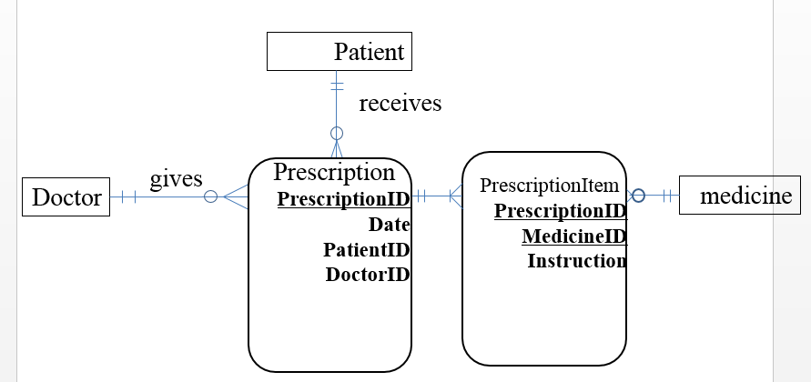

**SUBMISSION INSTRUCTIONS:**

Please submit your lab report in one **MS WORD** file to BlackBoard. Name your file in this format “IST659- lab1-Lastname-Firstname.docx”. For each of the above two problems, you need to include the following two sections.

1. Provide the business rules for your database design. Especially, if we ask you to create the rules by yourself.
2. Screenshots of your ERD diagram that is created using Visio.

(1) Create necessary entities, and give appropriate names to them.

(2) Add entity attributes. Make sure the attributes are at atomic level using good naming conventions (no composite **attribute**, no multi-value attribute).

(3) Set up primary key(s) for each entity.

(4) Establish relationships between entities. Give the relationships appropriate and recognize the associations (foreign keys).

(5) Mark correct cardinality of the relationships, and their cardinality constraints.

(6) Remember to declare **necessary assumptions** **(business rules)**, if they cannot be presented using the existing symbols of an ERD. For example, if there is a calculation formula to calculate the value of a derived attribute, you may want to add a note aside to the attribute in your ERD.

1. Screenshots of your Access tables and sample records, including:

(1) the datasheet views of each table

(2) data relationship model

**GRADING CRITERIA:**

* Appropriate Keys assigned (Primary Keys and Foreign Keys), Required and optional attributes 2pts -> 0.5 points will be deducted for every mistake made
* Correct cardinality according to the assumptions or given conditions 1pt -> 0.25pt will be deducted for every mistake made
* Datasheet view of tables in Access with data 0.5pt
* Data relationship model in Access 1pt
* Understandable font and clear ERD screenshot 0.5pt

**Total: 5pt**